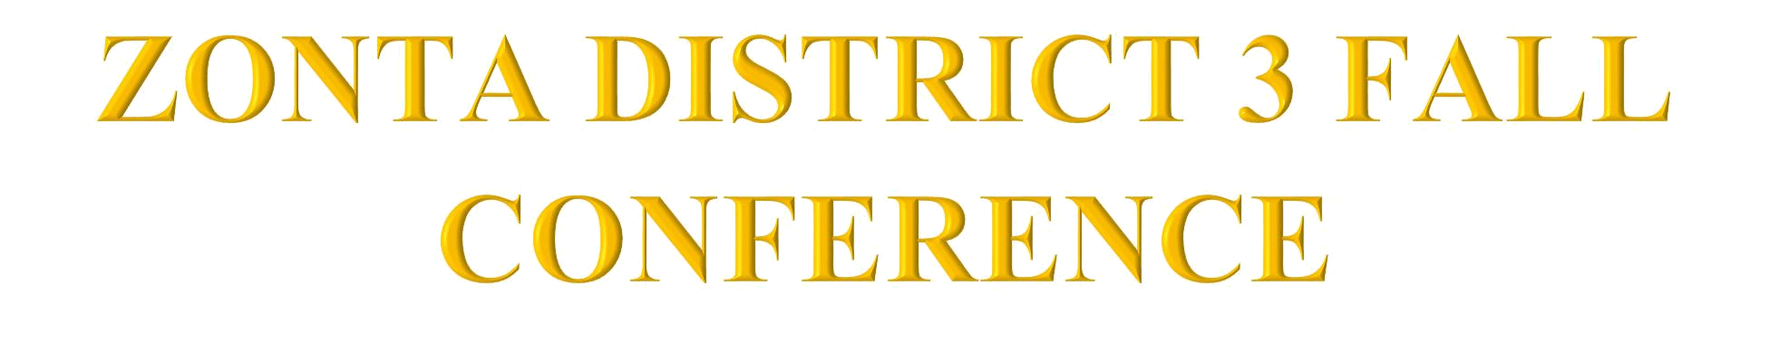





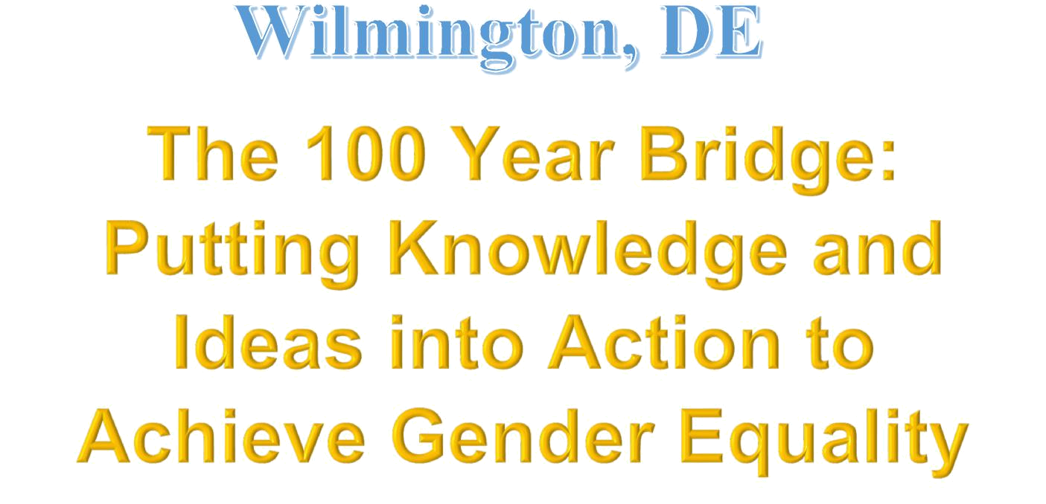

• | ACHIEVEMENT AWARDS | MEMBERSHIP AWARDS
• | CENTENNIAL AWARDS | SCHOLARSHIP RECOGNITION
• | CLUB VOTING | SURPRISES and MORE
- 2020-2022 DISTRICT 3 BOARD ELECTION

