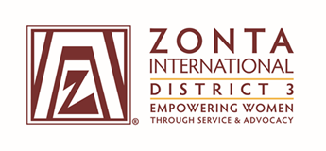

Service Committee Report

2016-2017

Club Name: ____________________________________________________________

Individual Completing Report: ____________________________________________

Preparer’s e-mail address: ________________________________________________

Preparer’s telephone number: _____________________________________________

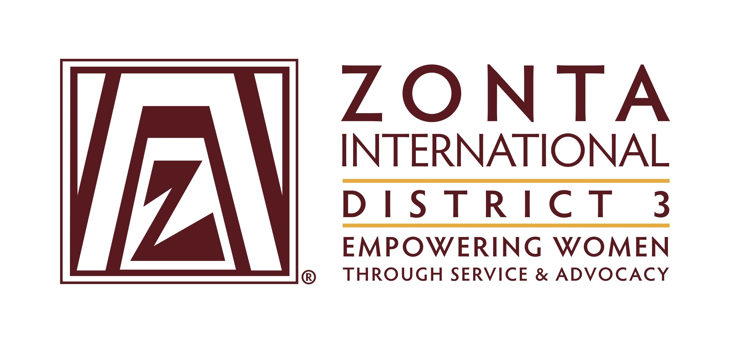
SERVICE COMMITTEE REPORT
2016-2017

Instructions
Following the guidelines below, send your completed report form by mail or email, postmarked no later than 30 June 2017, to:

- D3 Service Chair, Nancy Ramsay, nramsay2@gmail.com, 42716 Vineyard Terrace, Ashburn, VA 20147
      - Governor Donna Clark, donna.clark1@verizon.net, 3335 Elsa Avenue, Waldorf,
MD 20603
- Area Director for your Club:
- A1 – Suzanne Scalcione, scal346@aol.com, 346 Littleworth Lane,
Sea Cliff, NY 11579
- A2 – Pamela Morgan, pemorgan@aol.com, 231 West 6th Avenue
Roselle, NJ 07203
- A3 – Debra Crum, dlc13@comcast.net, 643 Springhouse Lane,
Hummelstown, PA 17036
- A4 – Carol Beechler, candlecrew04@yahoo.com, 10301 Amberleigh Court,
Manassas, VA 20110

District Goals

- District 3 supports International Service Programs and ZISVAW projects
  - Clubs devote time to share information and updates about ZI service projects in Liberia, Madagascar, Niger and Nepal.

- District and club projects are in-line with our mission and vision
  - One hundred percent of clubs have all local projects focus on women’s and girls’ issues. Develop and implement one service project. (May be combined with advocacy project.)
  - Cooperative projects will only be undertaken with like-minded organizations.

Report Guidelines
Describe your club’s service project(s)/activities, including what you did, what the project/activity accomplished, how many people were affected by it, how it met ZI’s goals on the local/international level, the percentage of your club members who were involved in the project/activity and how your community was made aware of your project/activity. Include copies of brochures, publications, fliers, meeting agendas and media coverage of projects and events.

Describe any program that your club sponsored that was directly related to the Zonta International service projects for this biennium.

Describe whether your club participated in the Young Women in Public Affairs or the Jane M. Klausman program. If your club participated in either or both of these, include the amount of your local award and how the recipient was honored by your club.

List the total amount of service hours performed and differentiate between general service hours, fund raising hours and “hands on” service hours.

Describe how your club’s projects/activities improved the status of women.

Describe your club involvement in a Z Club or Golden Z Club, and any activities related to those organizations.

List the amount of contributions your club made:

Total ZI Foundation contributions and participation

  - International Service Projects
  - Rose Fund
  - Amelia Earhart Fellowship Fund
  - Jane M. Klausman Women in Business Scholarship Fund
  - Young Women in Public Affairs Fund
  - ZISVAW
  - World Headquarters Property Preservation and Improvement Fund
  - Endowment Fund

Total local contributions

Of the total local contributions, list the local service organizations for women to which your club contributed, and the amounts/values donated.

