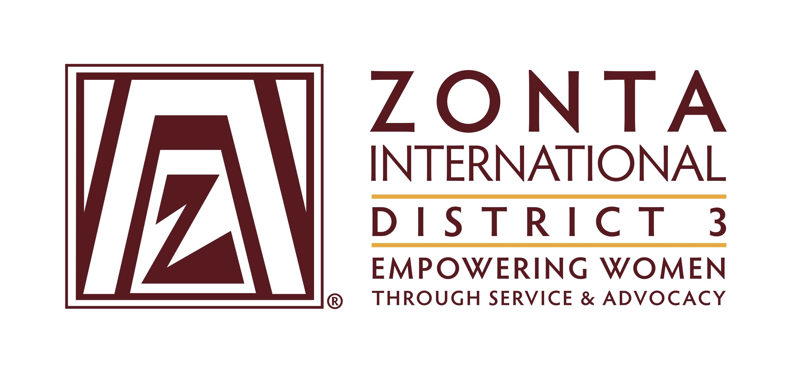

Zonta Club President Year Summary June 2017- May 2018

Service

The service committee continued to use the "Umbrella Concept" for programming, where more than one committee plan and work together. This allows the abilities for committees under the direction of a board member as one of her duties, to carry out activities which could not be accomplished alone. It also allows members to share their expertise, experiences and to have a sense of support to each other's committee. Further, it increases brand and public awareness through consistent messaging and programming. For example, by using the umbrella concept, there was a joint effort of the members on the service, advocacy and public relations committees to complete a lactation room at the new Prince Georges Family Justice Center. the ceremony and opening of the Family Justice Center; and the lactating room that was sponsored by the Zonta Club of Mid-Maryland.

Local Service Project

Prince George’s County Family Justice Center-Lactation Room

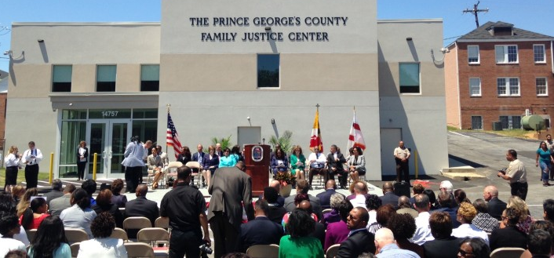

The Prince George’s County Family Justice Center was designed to offer victims of domestic violence, human trafficking and elder abuse with a place where they could get the services they need without having to go from one end of the county to the other to get help.

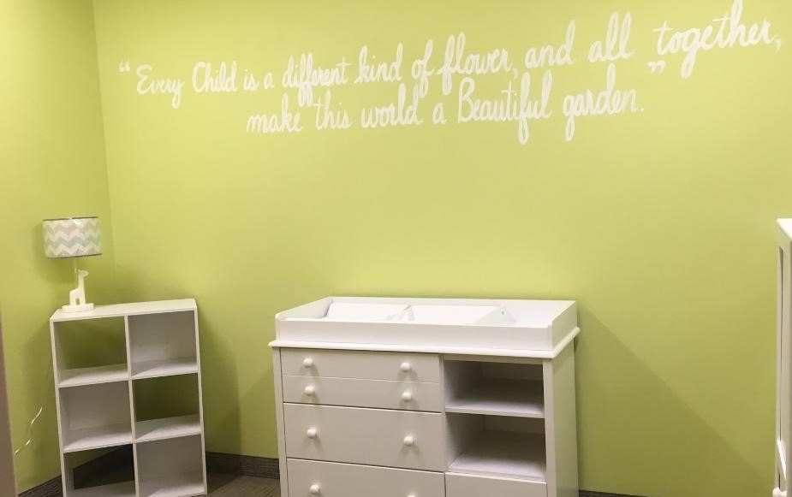

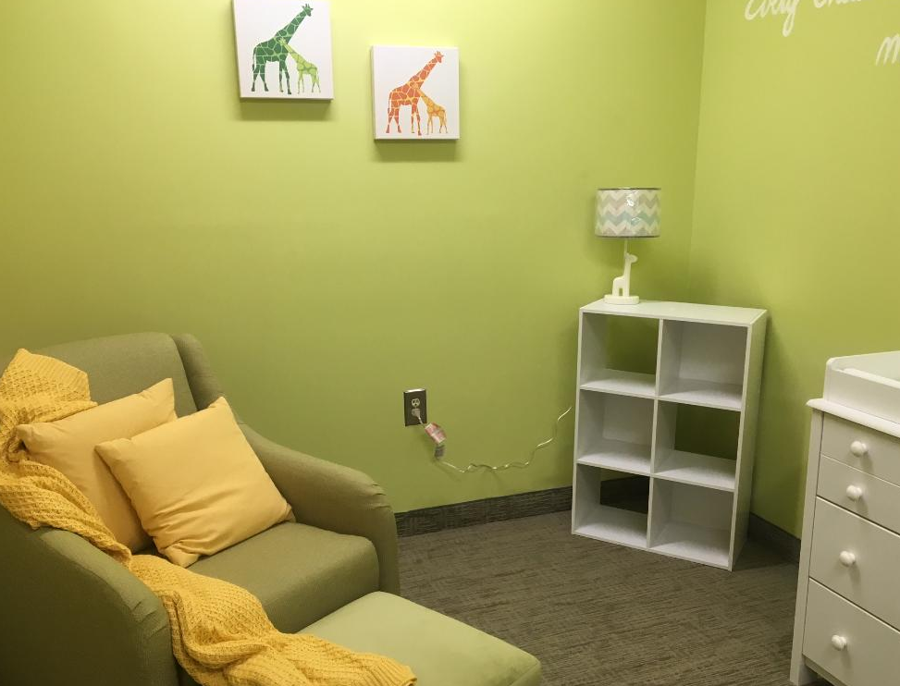
Zonta Club of Mid-Maryland members participated in the opening ceremony of this center and sponsored its Lactation Room. Our members design, painted, and completely furnish the lactation room.

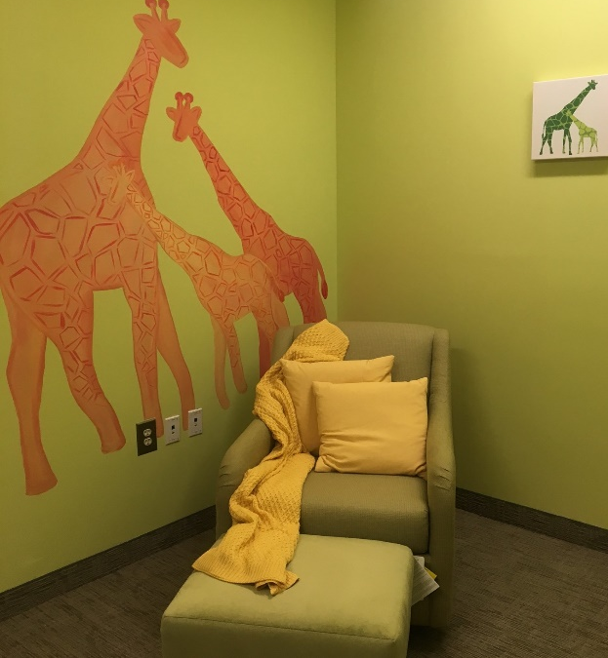

The cost of this project was $3,500 and approximately 100 service hours were provided by members of the
service, advocacy, and social media committee to complete this project

Free the Girls Bra Campaign:

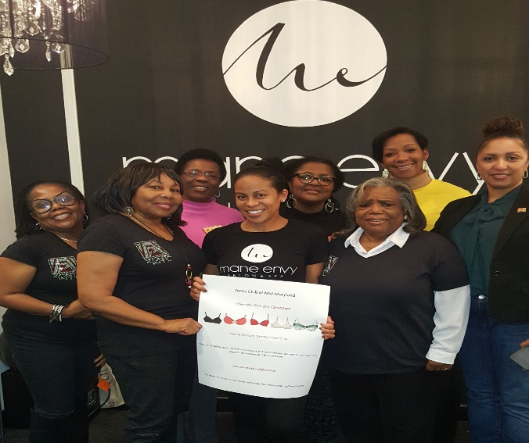

The Zonta Club of Mid-Maryland continued its program to collect new and gently used bras for Free the Girls, an organization devoted to helping girls rescued from sex trafficking. Mozambique, El Salvador, and Uganda are just three of the countries that face high numbers of human trafficking and modern-day slavery. Survivors can earn a safe income selling bras in the second-hand market place. Zonta collected bras at our meetings and events to donate to Free the Girls, is an ongoing program and the bras are collected at club meeting and in partnership with at Mane Envy Salon & Spa in Bowie, Maryland.

A press release was issued to launch the event and members were given copies of the flyer to publicize the program. In addition, a large poster and an elegantly decorated collection box were created for the Mane Envy Salon & Spa to publicize and collect the bras. Thus far, 84 bras have been sent to the Free the Girl. This service project has been enthusiastically embraced and supported by all members of the Zonta Club of Mid-Maryland. By collecting and donating bras, we are helping a woman establish and maintain her own business in the developing world.

Zonta Club of Mid-Maryland Scholarship

Zonta Club of Mid-Maryland created a Zonta Club of Mid-Maryland Scholarship for young mothers attending Prince George’s Community College. This scholarship will be awarded annually. It is designed to help young mother pay for added expenses related to obtaining childcare, transportation, and food while attending Prince George’s Community College. The 2018 award is $1,500 dollars. The scholarship is publicized in the Prince George’s Community College Fall Scholarship Guide. Our scholarship is on page 27 of the guide.

Zonta Club of Mid-Maryland Suit Project for Formerly Incarcerated Women.

Members are asked to bring gently used suits to our monthly club meetings. The suits are collected and will be donated to help formerly incarcerated women who are seeking employment.

Zonta Club of Mid-Maryland Scarf Project

Zonta Club of Mid-Maryland had a local vendor create scarves for the members of Zonta Club of Mid-Maryland to wear to public events to help identify themselves as members of the Zonta Club of Mid-Maryland. For example, the members wore the scarves when they participated in Zonta Day in Annapolis, Maryland and at the Zonta Anti Trafficking Symposium in Laurel Maryland. This initiative was enthusiastically embraced by the club members and 38 of the members purchased the scarves.

Young Women in Public Affairs Award Program

The Zonta Club of Mid-Maryland (ZMM) participated in the 2018 Young Women in Public Affairs Award Program. The service committee notified all high schools in Prince George’s County Maryland about the award criteria, as well as issued a press release, and placed information about the program on the ZMM website, Facebook, and Twitter. Megan Coe of Oxon Hill High School in Oxon Hill, Maryland received the 1st place award of $500, and Lauren Miller of Suitland High School in Forestville, Maryland received the 2nd place award of $250.

The award winners were honored at the Zonta Club of Mid-Maryland’s April 12, 2018 club meeting where they and their parents enjoyed the club dinner and were presented respectively with 1st and 2nd place certificates and their monetary awards. During the award ceremony the awardees were interviewed by the award presenter and did a great job in answering questions about their aspirations and public affairs goals. A press release was issued publicizing information about the award and the two winners. Attached is a copy of the press release and the letter sent to Prince George’s County principals requesting them to notify their students about the YWPA award.

Zonta International Jane Klausman Women in Business Scholarship

The Zonta Club of Mid-Maryland sought applications for the Jane Klausman Women in Business Scholarship. There were no awards available at the club level for the 2017/2018 plan year. However, the club solicited applications for scholarships at the district/region and international levels. The club publicized information about the scholarship via a press release and the Zonta Club Mid-Maryland website: www.zontaclubofmidmaryland.org. No applications have been received.

Human Trafficking Symposium

The Zonta Club of Mid-Maryland, The Prince George’s Human Trafficking Task Force, The Maryland Commission for Women and The Prince George’s Commission for Women hosted “A Symposium on Human Trafficking: Moving from Awareness to Action”.
The symposium was held on Saturday, April 21, 2018, from 10:30 am to 3 pm, at the Laurel Public Library, 507 7th Street, Laurel, Maryland 20707. There was no cost to attend. However, pre-registration was required. Lunch was provided to all pre-registered participants.

The purpose of the event was to collaborate with stakeholders, including government agencies, education officials, service providers, and non-profit organizations, to share important facts and figures about the topic as well as increase awareness regarding each stakeholder’s role in combatting human trafficking. The symposium included presentations and panel discussions describing the experiences of the victims of human trafficking along with current efforts at reducing human trafficking throughout the region. As part of our advocacy and service joint project, we distributed gift bags, water bottles, pens, note tablets and information about Zonta’s Human Trafficking campaign to “every” participant at the Symposium from Prince George’s County Human Trafficking Task Force. Also, we shopped and donated $150 worth of baby clothing to our guest speaker’s charity.

Membership/Mentoring

The Zonta Club of Mid Maryland continues to have a very strong and active membership. Our long term and short-term goals are to show a net increase in membership each year. There are two membership intakes: one based on attendance at a ZING; and the other based on the attendance of at least one meeting. Information is provided about Zonta at all service and advocacy events. We continue to hold retreats for members that are educational to also include a fun “Agenda”.

During each club year, members have at least attended an area, district or international meeting. After the meetings a report is given back to the body of the Club. Delegates are provided registration and hotel expenses. Members who are not officers are provided registration or part registration. Our Club President was the delegate to the Zonta International Conference in Yokohama Japan.

Finally, our members understand that they are expected to help each other no matter what committee they are serving own. Members provided good support and participation in our advocacy, service and fundraising activities.

Advocacy
The Zonta Club of Mid-Maryland was very active in 2017-2018 as we participated in many advocacy programs and events. We were effective advocates and community leaders on women’s issues. We actively engaged in advocacy activities to improve the status of women in the areas of education, health, legal, political and human rights issues such as violence against women and human trafficking. We supported legislation that advanced the objective of Zonta and its commitment to women. We collaborated with liked-minded organizations who shared our goals and helped us to further our mission. We developed and implemented combined advocacy and service projects.

November 18, 2017

Maryland Legislative Agenda for Women Conference

Members of the Zonta Club of Mid-Maryland attended the MLAW Fall Agenda Conference: “Mobilizing the Power of Maryland Women in a Time of Uncertainty,” at Howard Community College in Columbia, Maryland. MLAW is a statewide coalition of women’s groups and individuals formed to provide a non-partisan, independent, voice for Maryland women and families. The group advocates for progressive legislation and policy that promotes and protects the well-being of Maryland women and their families and provides them opportunities to develop their full potential. The conference was outstanding and featured several informative workshops, a keynote speaker, and state representatives presented a summary of pending legislation in Maryland that affects women and children. During the Fall Agenda Conference, club members networked with several women from various organizations throughout the state. We also told the women we met all about Zonta, including our priorities, and our mission. At the conference, 19 proposals were presented for consideration for the 2018 legislative agenda.

December 6, 2017

Zonta International’s 16 Days of Activism - Declared by Zonta International on a worldwide basis from November 25, 2017 – December 10, 2017, members of the Zonta Club of Mid-Maryland supported the Prince George’s County Office of the Sheriff and Leadership Prince George’s by attending their annual holiday mixer and teddy bear donation drive at SoBe Restaurant and Lounge located at 10621 Greenbelt Road, #201, Lanham, MD 20706. The purpose of this event was to mobilize citizens in Prince George’s county and to help boost morale of children that become victims affected by domestic violence by giving them a teddy bear. During this event, members of the Zonta Club of Mid-Maryland talked to more than 50 attendees about Zonta’s commitment and mission to end domestic violence and passed out Zonta’s Says No to Domestic Violence literature.

December 7, 2017

On Thursday December 7, 2017, members of Zonta Mid-Maryland Club greeted shoppers at the meeting room at Wegman’s Grocery Store in Woodmore Towne Center located at 9001 McHugh Drive, Lanham, MD 20706. Club members talked to several individuals about Zonta International, Inc. and Zonta’s desire and commitment to end domestic violence. Club members also passed out Zonta Says No to Domestic Violence literature, and pamphlets addressing domestic violence from the Prince George’s County Family Justice Center, an organization that provides an array of co-located services for survivors of domestic violence, sexual assault, human trafficking, and elder abuse.

December 9-10, 2017

To culminate our 16 days of activism in Prince George’s County, MD, members of Zonta’s Mid-Maryland Club set up a Stepping Out of Domestic Violence Shoe Exhibit with the assistance of Former County Council Member Karen Toles on Saturday December 9,
2017 and Sunday December 10, 2017 at the Shops at Iverson located at 3737 Branch Avenue, Temple Hills, MD 20748. The purpose of the exhibit was to encourage local citizens to take action to become aware of and strive to eliminate violence against women
And girls throughout the year.

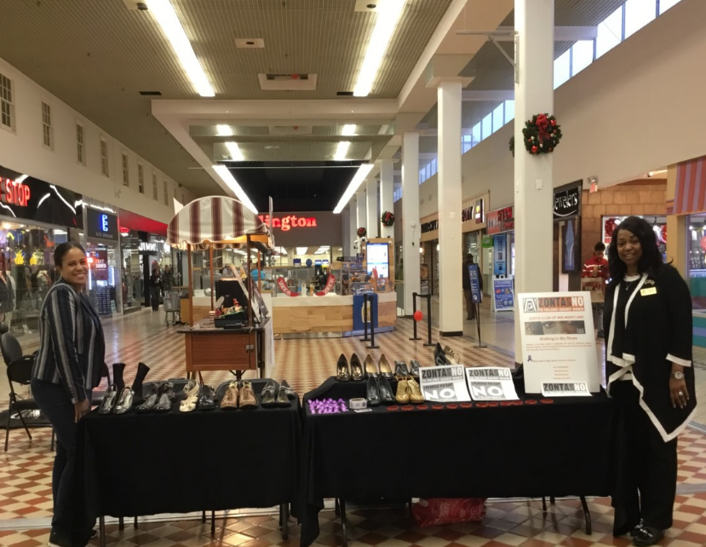

The exhibit consisted of a collection of barely used shoes that were placed in a central location inside the mall and served as a silent vigil against domestic violence. The display represented local women and children who were killed because of domestic violence and those who have survived, left violent relationships and rebuilt their lives. There is a personal story behind each pair of shoes such as a story of survival or a story of hope.

While at the Shops at Iverson, club members spoke to several holiday shoppers about Zonta’s mission and commitment to end domestic violence, including victims of domestic violence and those whose relatives were incarcerated because they committed domestic violence crimes. Club members also passed out purple ribbons in honor of domestic violence month, stickers, pamphlets, and Zonta Says No to Domestic Violence literature. Our hope is that the Stepping Out of Domestic Violence exhibit not only raised the level of awareness about domestic violence, but that it encouraged members of our community to engage in dialogue and action that can help eradicate this problem.

Now that the 16 Days of Activism is over, the Zonta Club of Mid-Maryland will donate all the shoes to a local domestic violence shelter or women’s shelter.

Women’s Legislative Briefing

January 28, 2018

Members of the Zonta Club of Mid-Maryland attended the Montgomery County Commission for Women the 38th annual Women's Legislative Briefing on January 28, 2018 from at The Universities at Shady Grove.
We heard from advocates, elected officials, and policy professionals on a variety of topics including Education, Health Care, Economic Justice, and Human Trafficking. In addition, it is a great opportunity to meet change makers in our community.

2018 Domestic Violence Memorial Service

February 12, 2018

Zonta Club of Mid-Maryland and Zonta Club of Annapolis joined with community leaders throughout Maryland to remember those whose lives were lost because of domestic violence, bring awareness to the problem of domestic violence in Maryland, and propose legislative changes to support survivors.

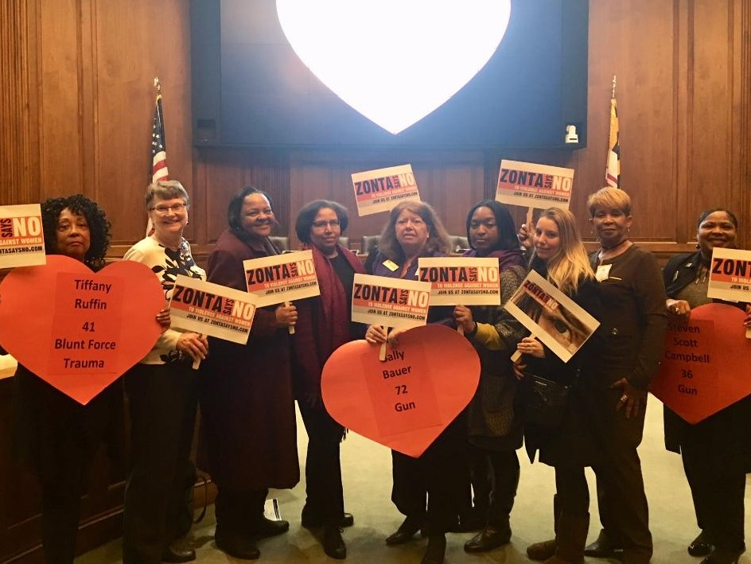

March 6, 2018

Members of the Zonta Club of Mid-Maryland attended the 11th Annual Links at the Legislature at the Lowe House Office Building in Annapolis, Maryland. The purpose of this event was to network with members of the various Links chapters across the state and to advocate for house bills affecting the health and education of children in Maryland. The day started with a legislative update on several bills, as well as several presenters discussed issues related to children’s mental health, impact of the opioids epidemic on children, and financial wealth vs. high income. Club members were also joined by members of the Maryland General Assembly for lunch and a tour of the mansion.

March 16, 2018

Zonta Club Day in Annapolis

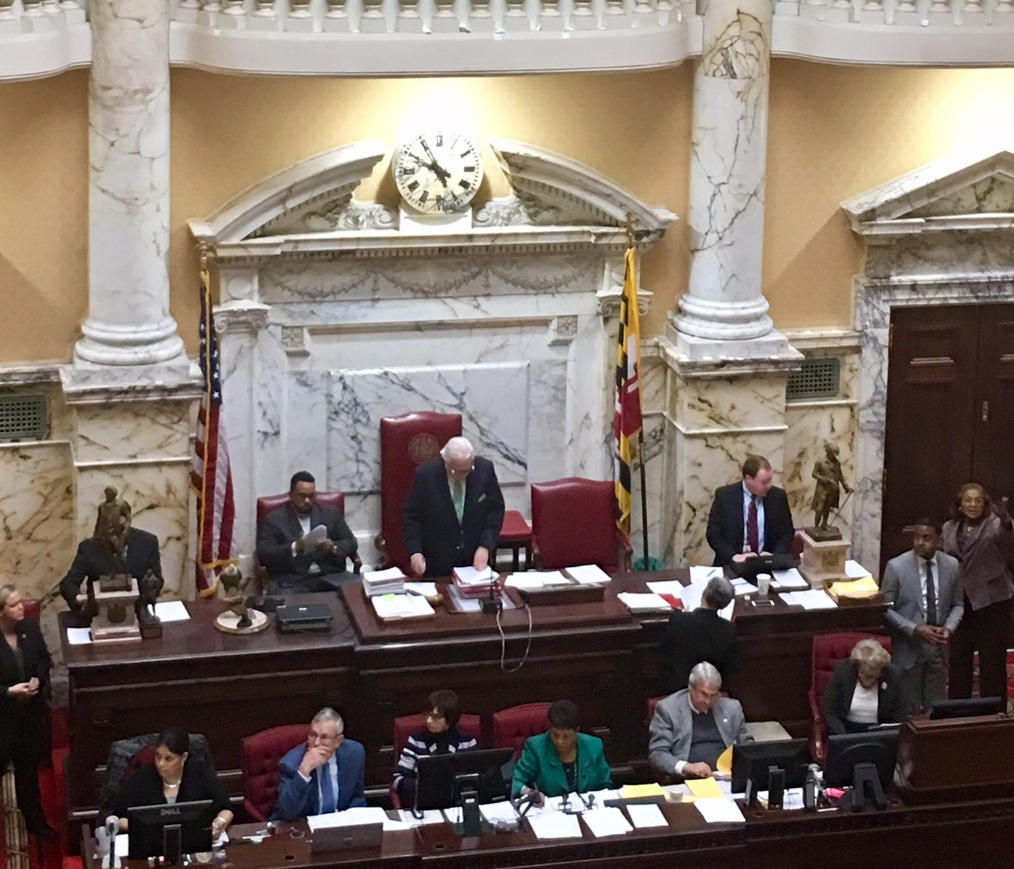

Members of the Zonta-Club of Mid-Maryland Co-hosted, along with Senator JoAnne Benson, our Inaugural Zonta Club Day in Annapolis. The purpose of Zonta Club Day in Annapolis was to raise Zonta’s visibility in Annapolis, and to advocate for bills affecting women and girls. Our first Zonta Club Day in Annapolis was a huge success. We stood out and received rave reviews for the yellow Zonta scarves and black suits that we wore. We began at 8:30 a.m. with a continental breakfast and we ended our day with a sisterhood luncheon for our club members. During the day, members of Maryland’s General Assembly, and the Executive Director of the Women’s Caucus in Maryland greeted us. We also toured the Maryland General Assembly and watched members of the Senate and the House debate and pass bills. Four members of our club were escorted on the floor of the Senate to observe the Senators debate and vote on legislation firsthand. In addition, Senator Benson gave us an outstanding introduction from the floor and we well receives by all in attendance.
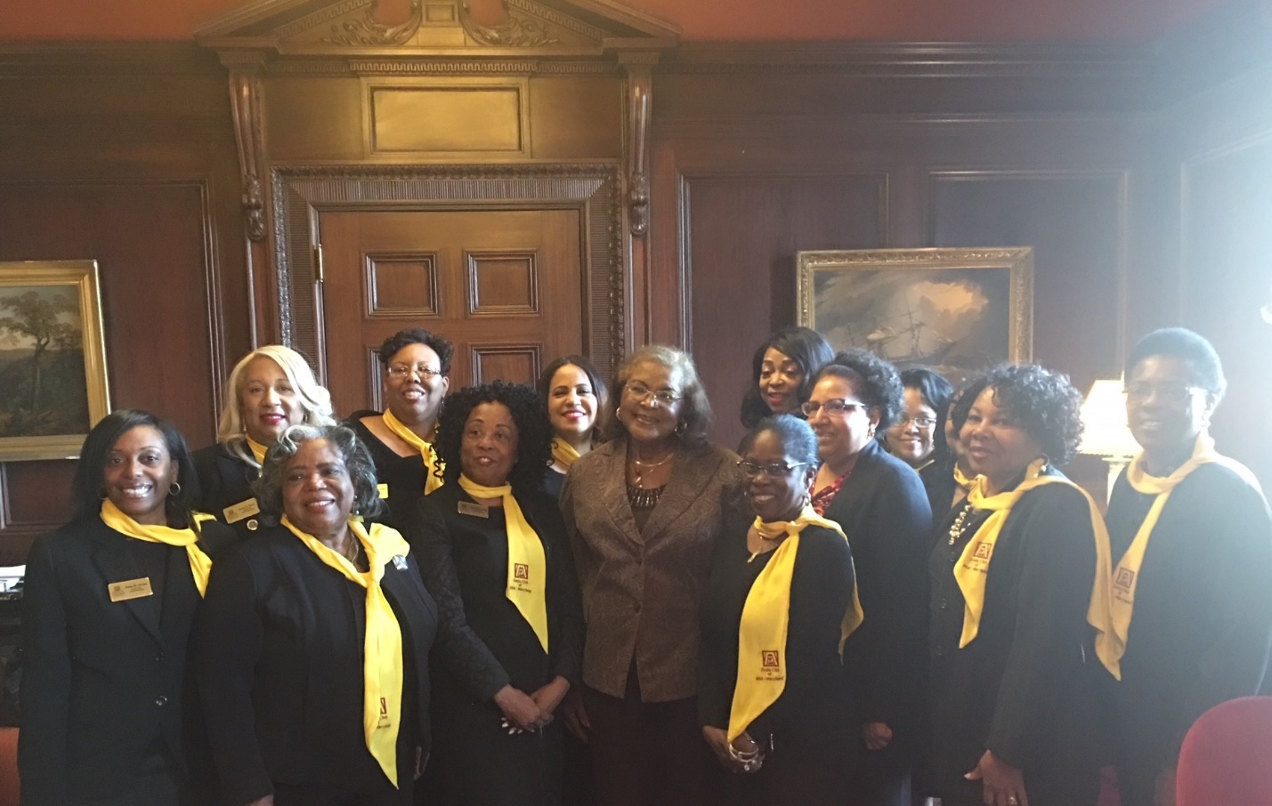

We were also escorted into the Senate lounge and were giving the opportunity to take pictures with Maryland State Senators. We invited all clubs in Maryland to collaborate on issues affecting women that we are all concerned about such as domestic violence and human trafficking. Our Sponsors were: (1) Professional Care Pharmacy that donated journals; and (2) Prince George’s County Family Justice Center that donated pens and brochures.

Below is a list of Senate and House Bills that Zonta advocated and supported during Zonta Club Day while in Annapolis.

Repeat Sexual Predator Prevention Act (HB301/SB270) - Maryland law strictly limits introduction of evidence of other sex crimes in sex assault and child molestation trials, making it extremely difficult to rebut false consent defenses or allegations that a child victim is lying. This legislation will enable prosecutors to introduce evidence of a defendant’s sex crimes and allegations of sex crimes against different victims, in addition to introducing this type of evidence in cases with the same victim (as established by the MD Judiciary). This legislation requires a thorough judicial review before the evidence can be used. The State must file a motion to introduce the evidence at least 90 days before trial. The Court must hold a closed-door hearing to determine the admissibility of the evidence allowing the defense to challenge evidence’s admissibility. The Court must find that the evidence meets clear and convincing evidence standard. The Court may also consider factors related to similarities between evidence the State wishes to admit and the trial offense.

Expansion of Maryland’s Vacating Laws for Survivors of Human Trafficking (HB1267/SB869) - Victims of human trafficking are commonly arrested and convicted for crimes they were forced to commit by their traffickers. In response to this injustice, Maryland became the second state in the county to pass a law allowing survivors of sex trafficking to vacate, or, set aside, their prostitution convictions. Since then, anti-trafficking advocates throughout the country have documented that survivors of trafficking are regularly charged with numerous offenses other than prostitution, and that labor trafficking survivors experience criminalization tied to their victimization. In Maryland, however, access to this innovative form of legal relief remains limited only to survivors of sex trafficking who are convicted of prostitution. The proposed change in law will expand Maryland’s current vacatur law to apply explicitly to survivors of labor trafficking, as well as expand the number of crimes eligible for vacatur. Without these changes, Maryland’s vacatur law will continue to leave many survivors without the legal relief they so desperately need to heal from the trauma of their exploitation and become productive members of their communities.

Healthcare Services for Pregnant Inmates (HB787/SB629) - This bill would require all state, local, and private detention and corrections facilities to have written policies regarding healthcare services for adult and juvenile pregnant inmates. The legislation would leave the authority to determine and write the policies up to the state, county, or private facility, but would require that the policies address specific subjects (this list is still in development and may change): pregnancy testing, pregnancy options counseling, prenatal care, prenatal testing and counseling, access to abortion care, miscarriage management, labor and delivery, and postpartum care. In addition, it would require all state, local, and private detention and corrections facilities to provide these written policies to all adult and juvenile inmates and detainees with positive pregnancy test results.

April 21, 2018

Human Trafficking Symposium

The Zonta Club of Mid-Maryland, The Prince George’s Human Trafficking Task Force, The Maryland Commission for Women and The Prince George’s Commission for Women hosted “A Symposium on Human Trafficking: Moving from Awareness to Action”.
The symposium was held on Saturday, April 21, 2018, from 10:30 am to 3 pm, at the Laurel Public Library, 507 7th Street, Laurel, Maryland 20707. There was no cost to attend. Lunch was provided to all pre-registered participants.

The purpose of the event was to collaborate with stakeholders, including government agencies, education officials, service providers, and non-profit organizations, to share important facts and figures about the topic as well as increase awareness regarding each stakeholder’s role in combatting human trafficking. The symposium included presentations and panel discussions describing the experiences of the survivors of human trafficking along with current efforts at reducing human trafficking throughout the region. As part of our advocacy and service joint project, we distributed gift bags, water bottles, pens, note tablets and information about Zonta’s Human Trafficking campaign to “every” participant at the Symposium from Prince George’s County Human Trafficking Task.

Other: Fundraising

The Zonta Club of Mid-Maryland held its annual February, 2018 Dinner & Dance. This year’s theme was a Masquerade Ball. in just two years, in total our club grossed more that $32,000.

In conclusion, it has been a privilege to serve as President of this Club. The success of the Club should be credited to the very dedicated Board and Members of the Zonta Club of Mid-Maryland.

